Το UML των κλάσεων που χρησιμοποιήσαμε τόσο στην JAVA όσο και στην C++ είναι το παρακάτω:

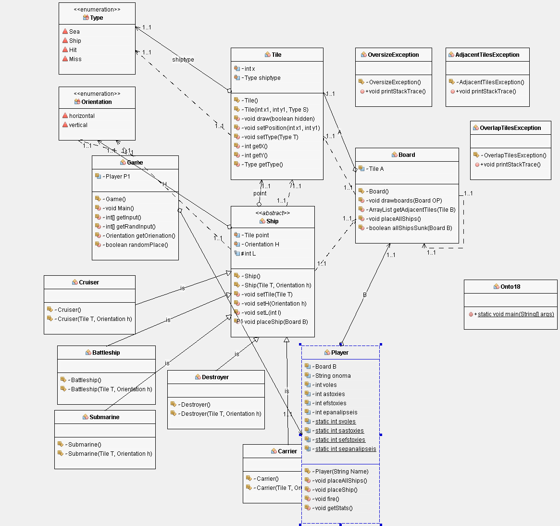

Όπως βλέπουμε έχουμε τις παρακάτω κλάσεις:

enum Type {

Sea, Ship, Hit, Miss

};

enum Orientation {

horizontal, vertical

};

class Tile

{

private int x,y;

private Type shiptype;

Tile()

Tile(int x1,int y1, Type S)

void draw(boolean hidden)

void setPosition(int x1,int y1)

void setType(Type T)

int getX()

int getY()

Type getType()

}

class OversizeException extends Exception

{

OversizeException()

@Override

public void printStackTrace()

}

class OverlapTilesException extends Exception

{

OverlapTilesException()

@Override

public void printStackTrace()

}

class AdjacentTilesException extends Exception

{

@Override

public void printStackTrace()

}

abstract class Ship

{

private Tile point;

private Orientation H; // katefthinsi

protected int L; // megethos

Ship()

Ship(Tile T, Orientation h)

void setTile(Tile T)

void setH(Orientation h)

void setL(int l)

void placeShip(Board B) throws AdjacentTilesException, OversizeException, OverlapTilesException

}

class Carrier extends Ship

{

Carrier()

Carrier(Tile T, Orientation h)

}

class Battleship extends Ship

{

Battleship()

Battleship(Tile T, Orientation h)

}

class Cruiser extends Ship

{

Cruiser()

Cruiser(Tile T, Orientation h)

}

class Submarine extends Ship

{

Submarine()

Submarine(Tile T, Orientation h)

}

class Destroyer extends Ship

{

Destroyer()

Destroyer(Tile T, Orientation h)

}

class Board

{

Tile A[][]=new Tile[7][7];

Board()

// ektyposi tou pinaka tou paikti kai tou antipallou OP

void drawboards(Board OP)

// vazoume se ena arraylist ta geitonika simeia tou keliou B

ArrayList getAdjacentTiles(Tile B)

void placeAllShips()

boolean allShipsSunk(Board B){

}

class Game

void Main()

int[] getInput()

int[] getRandInput()

Orientation getOrienation()

boolean randomPlace()

}

class Player

{

Board B;

String onoma;

int voles;

int astoxies;

int efstoxies;

int epanalipseis;

static int svoles;

static int sastoxies;

static int sefstoxies;

static int sepanalipseis;

Player(String Name)

void placeAllShips()

void placeShip()

void fire()

void getStats()

}

Η ίδια λογική ακολουθείται και στην C++;